Xavier Guay
Computer Vision
Assignment 1
Due: February 11, 2016

Objective
This assignment has two main goals. The first is to display the left half of a given image. The second goal is to shrink an image by half in both length and width.

Background
Most of this assignment revolves around learning how to use xv to open binary images. This subject was covered in a lab tutorial we had two weeks ago.
Another large part of this lab is the manipulation of the image. Part 1 focuses on the cropping of images by removing pixels in groups while part 2 focuses on the scaling of the image which is done by uniformly removing pixels across the whole image.

Algorithm
There are two algorithms that are used in these two programs. Part 1 uses a algorithm to crop the right half of the image out. This is done by copying only the first half of each row of pixels into the new image. Part 2, the shrinking of an image, is done by removing every other pixel in a row and every other row.

Results
For the most part this lab went well. There was some challenges with getting the image to display correctly because the wrong g++ complier settings were used. Part 1 of this lab took the original image as shown in Figure 1.1 and copied it into a new file. During the copying process it leaves out the second half of each row making it so that it only leaves the left half of the image as shown in Figure 1.2.

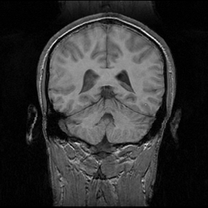
Figure 1.1

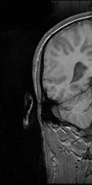
Figure 1.2

Part 2 of the assignment takes the same input figure, once again Figure 1.1, and shrinks it by leaving out every other pixel in each row, and leaving out each column. This effectively reduces the size of the image in half by both length and width, or a quarter of it's original size. This can be seen in Figure 1.3.

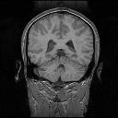
Figure 1.3
Conclusion and Observations

As you can see by the above figures the programs function correctly. This experiment allowed the methods of scaling and shrinking to be explored and better understood.

